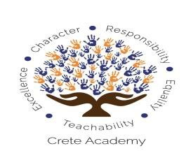

SPECIAL BOARD MEETING
Agenda
February 18, 2020, 7:00 PM
info@creteacademy.org (323-791-1600)
Conference Line: 712-770-5505; PIN: 173509
6103 Crenshaw Boulevard, Los Angeles, CA
333 South Hope Street, 43rd Floor, Los Angeles, CA
7311 N Figueroa Street, Los Angeles, CA
1346 West Rosecrans Avenue, Gardena, CA
- Welcome
- Public Comment: info@creteacademy.org (323-791-1600)
- Habits for Effective Board Training and Brown Act Updates- Representative from Young, Minney & Corr, LLP
Public Comment: the meeting location is wheelchair accessible. Speakers needing any disability related or language accommodation should notify the board Secretary a minimum of 24 hours in advance of the meeting to arrange for accommodations, and inform the staff upon arrival.

